KENDRIYA VIDYALAYA No.2, BOLANGIR

FORMATIVE ASSESSMENT- III (2013-14)

CLASS: III TIME: 1 Hr 30 Min

SUBJECT: EVS MAX. M: 40

NAME- _______________________________________ DATE: …..../01/2014

Class- III Sec___ Roll No._____ Invigilator’s Sign_______ Examiner’s Sign. ……

|  |  |  |  |
| --- | --- | --- | --- |
| OBSERVATION & REPORTING | IDENTIFICATION & CLASSIFICATION | DISCOVERY OF FACTS | OVERALL |
|  |  |  |  |

OBSERVATION AND REPORTING

1. 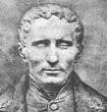 Whose photograph is this?

Answer:-

___________________________________________________________________

1. With whom do you share your feelings?

Answer:-

____________________________________________________________________

1. Where do we see an Igloo?

Answer:-

___________________________________________________________________

Fill in the blanks from the box:-

|  |  |  |  |  |  |  |  |
| --- | --- | --- | --- | --- | --- | --- | --- |
| Post man, |  |  | Camel, |  |  |  | Braille |

1. _____________ is called as the ship of the desert.
2. _____________ script is read by running the fingers on raised dots.
3. _____________ brings letters for us.
4. How many players are needed to play the given game.

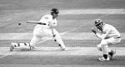 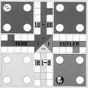

____________ ______________

1. How are the following animals helpful to us?

Answer:-

* 1. Dog _____________________
  2. Sheep ______________________

# IDENTIFICATON AND CLASSIFICATION

1. Where do we see the given house?

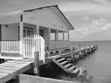 Answer_____________________________________________

State T for true and F for False Statements :-

1. Pots are baked in Kiln or Fire. _________
2. We get eggs from goats. _________
3. A potter needs potter’s wheel to shape the pot. _________
4. Write the names of any 2 Indoor Games

a) _________________________ b) ______________________________

1. Write the name of any 2 means of communication

a) ____________________ b) ______________________________

1. Differentiate between a Kuccha House and a Pucca House?

|  |  |  |
| --- | --- | --- |
|  | Kuccha House | Pucca House |
| 1. |  |  |
| 2. |  |  |

1. Draw a Green Circle around those items that we get from plants and Draw a Red Circle around those items that we get from Animals. .

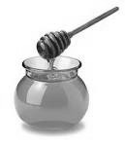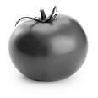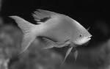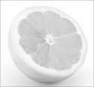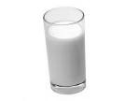

DISCOVERY OF FACTS

1. Match the following:-

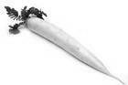 Roots

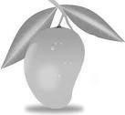 Leaves

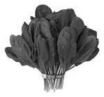 Fruit

1. Which medicine do you take from plants when you

Get hurt _________________

Have cold _________________

Tooth ache _________________

1. Write the name of 2 different types of pots made of clay.

Answer:-

a) ________________________ b) _________________________

20. Name any two domestic animals.

a) __________________________ b) __________________________

21. Write your School Address in the given POST CARD and write a letter to The Principal of Your School.

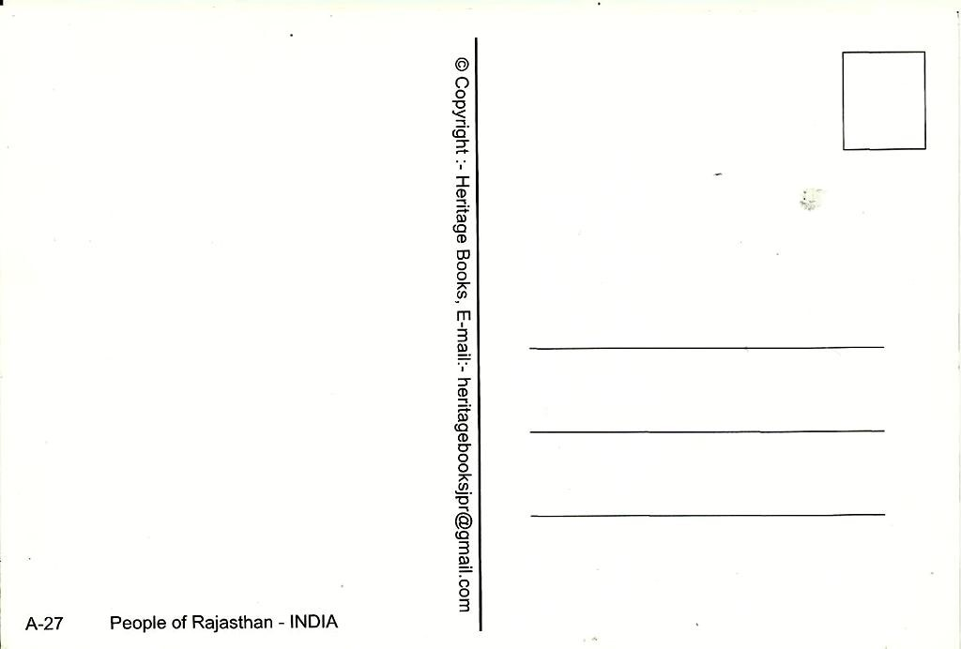

KENDRIYA VIDYALAYA No.2, BOLANGIR

FORMATIVE ASSESSMENT- III (2013-14)

CLASS: IV TIME: 1 Hr 30 Min

SUBJECT: EVS MAX. M: 40

NAME- _______________________________________ DATE: …..../01/2014

Class- IV Sec___ Roll No._____ Invigilator’s Sign_______ Examiner’s Sign. ……

|  |  |  |  |
| --- | --- | --- | --- |
| OBSERVATION & REPORTING | IDENTIFICATION & CLASSIFICATION | DISCOVERY OF FACTS | OVERALL |
|  |  |  |  |

OBSERVATION AND REPORTING

Q1. Mark the following states in Map with different colours and names

1. Assam
2. Maharashtra
3. Gujarat
4. Andhra Pradesh
5. Shade and name the state known for Wheat.

Answer _______________________________________

1. Mark and name the river Ganga.

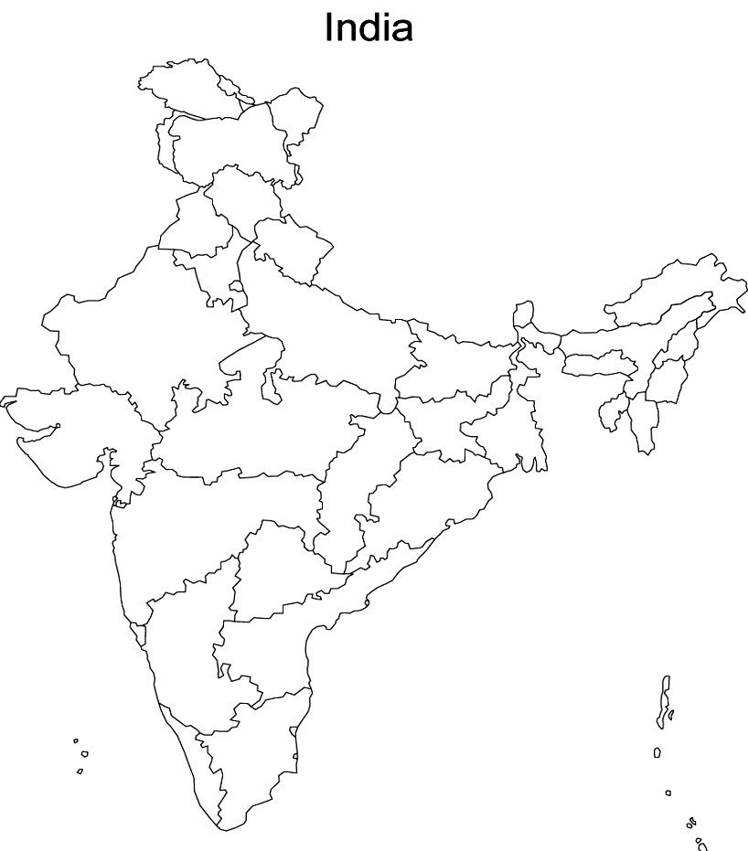

Q2. a) Name the picture and mention its use

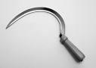 _____________________________

____________________________________________________________________________

____________________________________________________________________________

____________________________________________________________________________

b) Write any 2 differences between Village life and City life. Answer-

|  |  |
| --- | --- |
| Village life | City life |
|  |  |

# IDENTIFICATON AND CLASSIFICATION

Q3. a) Write the given fruits and vegetables in proper column

(Spinach, Potato, Banana, Tomato, Ginger, Grapes, Onion, Gourd)

# Spoil quickly Stay for some days

i) i) ii) ii) iii ) iii) iv) iv)

1. Circle the things which dissolve in water.

sugar , dal , cooking soda , oil , salt , lemon juice

1. Tick (  ) the vegetables which are rough to touch.
   1. Bitter gourd ( ) ii) apple ( ) iii) ginger ( ) iv) Jack fruit ( ) v) ginger ( ) vi) tomato ( )

1. Write what happen-
   1. If we are late to take out the onion crops then __________________ __________________________________________________________ __________________________________________________________. ii) If we do not remove the weeds from onions field then ____________ __________________________________________________________

__________________________________________________________.

1. Name two water contaminated disease .

Ans.___________________ _________________.

1. What different materials do, birds use build their nests ?

Ans: ________________________________________________________

________________________________________________________

________________________________________________________

Q4. Many steps are needed to grow crops. Look at the picture and name the work and write a paragraph on it in proper sequence .

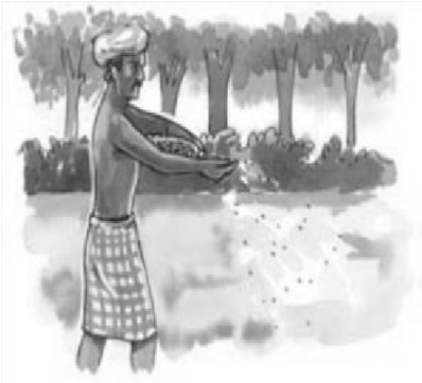 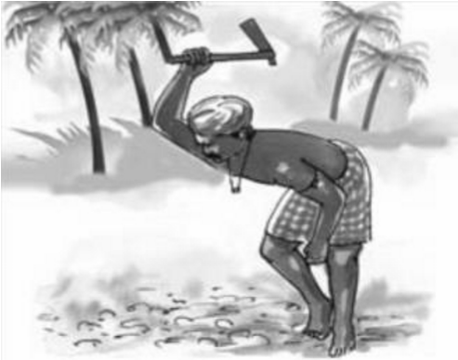 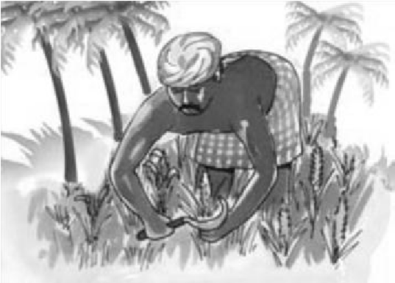

Ans: ________________________________________________________

________________________________________________________

________________________________________________________

________________________________________________________

________________________________________________________

________________________________________________________

DISCOVERY OF FACTS

Q 5 . Write True or False.

i) It is necessary to clean the water before we drink. ( ) ii) Vegetable sellers sprinkle water on vegetable to keep them fresh, clean and not to

dry.( )

iii) Langer is served in Church ( )

iii) Onam the harvest festival is celebrated in Kerala . ( ) v) Stems help to absorb water from the soil. ( ) vi) Bora is a variety of wheat used in Assam .( )

Q6. Answer the questions -

1. How can unclean or dirty water harm our body? Explain Ans. ________________________________________________________

________________________________________________________

________________________________________________________

________________________________________________________

1. Define the following terms.

1)Pollution

________________________________________________________

________________________________________________________

________________________________________________________

2) Irrigation_______________________________________________

________________________________________________________

________________________________________________________

Q7. Draw a labelled diagram of a plant to show the different parts .Write the main function of roots, stem and leaves .

KENDRIYA VIDYALAYA No.2, BOLANGIR

FORMATIVE ASSESSMENT- III (2013-14)

CLASS: V TIME: 1 Hr 30 Min

SUBJECT: EVS MAX. M: 40

NAME- _______________________________________ DATE: …..../01/2014

Class- V Sec___ Roll No._____ Invigilator’s Sign_______ Examiner’s Sign. ……

|  |  |  |  |
| --- | --- | --- | --- |
| OBSERVATION & REPORTING | IDENTIFICATION & CLASSIFICATION | DISCOVERY OF FACTS | OVERALL |
|  |  |  |  |

OBSERVATION AND REPORTING

A. Observe the following pictures and complete the sentences.

|  |  |
| --- | --- |
| 1) Vehicles stop at ____________ for fuel. |  |
| 2) ________________ is the national game of India. |  |
| 3) In Srinagar we find this    ________________ |  |
| 4) A _____________ is an instrument used to listen to the sound of heart beat. |  |
| 5) We blow air to produce sounds in the instruments  _____________ |  |
| 6) Name this famous Sports  person  __________________________ |  |

B) Answer the following.

1. Name any two musical instruments in which air is blown to produce sound.

i.________________________ ii. _____________________________

1. Write the names of two freedom fighter.

i._________________________ , ii. _____________________________

IDENTIFICATON AND CLASSIFICATION

A) Write, Who am I?

1. I am used to cook food. I am inside a red cylinder ___________.
2. I am a vehicle used to take patients to hospitals ____________.
3. I am the father of Indian constitution _______________.
4. I am a favourite game of people. People play this game with bat and ball _______________.

B. Short Answers-Answer all the questions.

1. Write two benefits of playing Games and Sports.

____________________________________________________________________________

____________________________________________________________________________ ____________________________________________________________________________

1. Classify the following game.

(Kabaddi, chess, table tennis, football)

Individual game Team game

_______________ ________________

________________ ________________

1. Differentiate as natural and man-made disasters.

(Earthquake, accident, deforestation, tsunami)

|  |  |
| --- | --- |
| NATURAL DISASTERS | MAN MADE DISASTERS |
|  |  |
|  |  |

C. Long Answer-

III Answer in detail.

Identify the person and write a about him.

____________________________________________

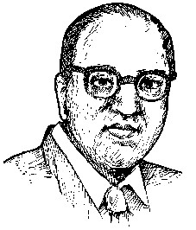____________________________________________

____________________________________________

____________________________________________

______________________________________________________

______________________________________________________

______________________________________________________

______________________________________________________

______________________________________________________

# DISCOVERY OF FACTS

A) Very Short Answer 1) Match the following.

# Personality Games

Dhanraj Pillai Tennis

P.T. Usha Cricket

Sachin Tendulkar Athletics

Sania Mirza Hockey

Saina Nehwal Weight-lifting

K . Malleshawari Badminton

2) Write the full form of the following.

LPG-___________________________________________________

CNG-___________________________________________________

B) Short Answers

1) We blow to cool hot things as well as to warm cool things. Give example.

____________________________________________________________________________

____________________________________________________________________________

____________________________________________________________________________

____________________________________________________________________________ ____________________________________________________________________________

C. Long Answer

1) Locate the following states in the map of India given below and write their capital.

|  |  |  |
| --- | --- | --- |
|  | State | Capital |
| a)Maharashtra |  |  |
| b)Assam |  |  |
| c) Gujarat |  |  |
| d)Punjab |  |  |
| e)Rajasthan |  |  |

